INTEGRATED POWER SOURCE FOR ELECTRON GUN FOR LINAC
35kV, 1kW

This power source was designed and developed for electron gun load to be connected to linac. This integrated power source includes a power supply for gun injection, cathode heating, , a DC and pulsed section for grid control.

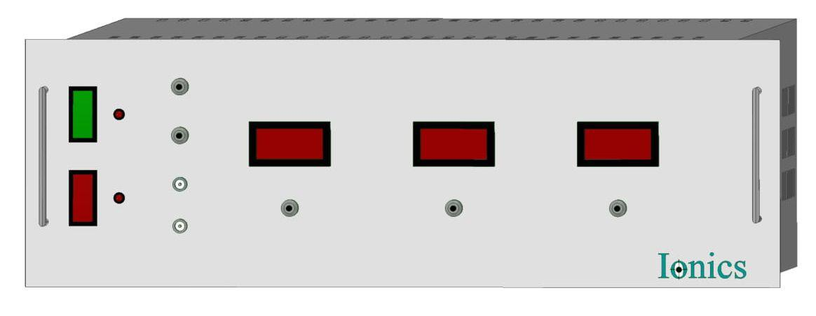
Features:
- Compact
- Consists of DC & pulsed section
- Good regulation

Gun Injection Power Supply:

Technical Specifications
PARAMETER | SPECIFICATION
Pulse height | Variable from 0kV to -35kV peak(max)
Maximum Current | 3A peak
Pulse shape | Rectangular
Pulse width (measured at the flat top) | Adjustable from 4μS to 12μS
Ruse time | 2.5μS
Flat top variation (peak to peak) | Flatness within 1% with initial overshoot less than 5% of the set value
Pulse Repetition Frequency (RPF) | Variable from 1 to 250 pps
Maximum reverse voltage | Less than 1.5kV
Maximum average power | 360W

Cathode Heater Power Supply:

Technical Specifications
PARAMETER | SPECIFICATION
Output Voltage | 10V A.C. max
Output Current | 10V A.C. max
Regulation | Poor regulation
Output Reference | Floating at -40kV (output of the gun injection power supply)
Output isolation | Minimum -40kV w.r.t. earth under pulsed condition. (Pulsed width: 12μS, PRF:250Hz)
Trip | 10Amp

Grid Power Supply
-1kV DC Section
PARAMETER | SPECIFICATION
Output Voltage | -1kV DC settable in steps of 100V; the Grid is at negative potential with respect to the cathode
Output Current | 200mA DC max
Pulse shape | Rectangular
Type of control | Voltage regulated with load regulation <_ ±0.1%
Output reference | Floating at -40kV (output of the pulsed gun injection power supply section)
Output isolation | Minimum -45kV w.r.t earth under DC condition.

1kV PULSED Section
Output Voltage (pulsed) | Pulsed amplitude settable from 1V to 1kV DC precisely variable in continuous manner. This pulse overrides the -1kV DC voltage at the grid
Pulse Shape | Rectangular
Pulse width (measured at the flat top) | Adjustable from 4μS to 10μS
Rise time | 0.5μS
Flat top variation (peak to peak) | Flatness within 1% with initial overshoot less than 5% of the set value.
Output Current | 10mA max.
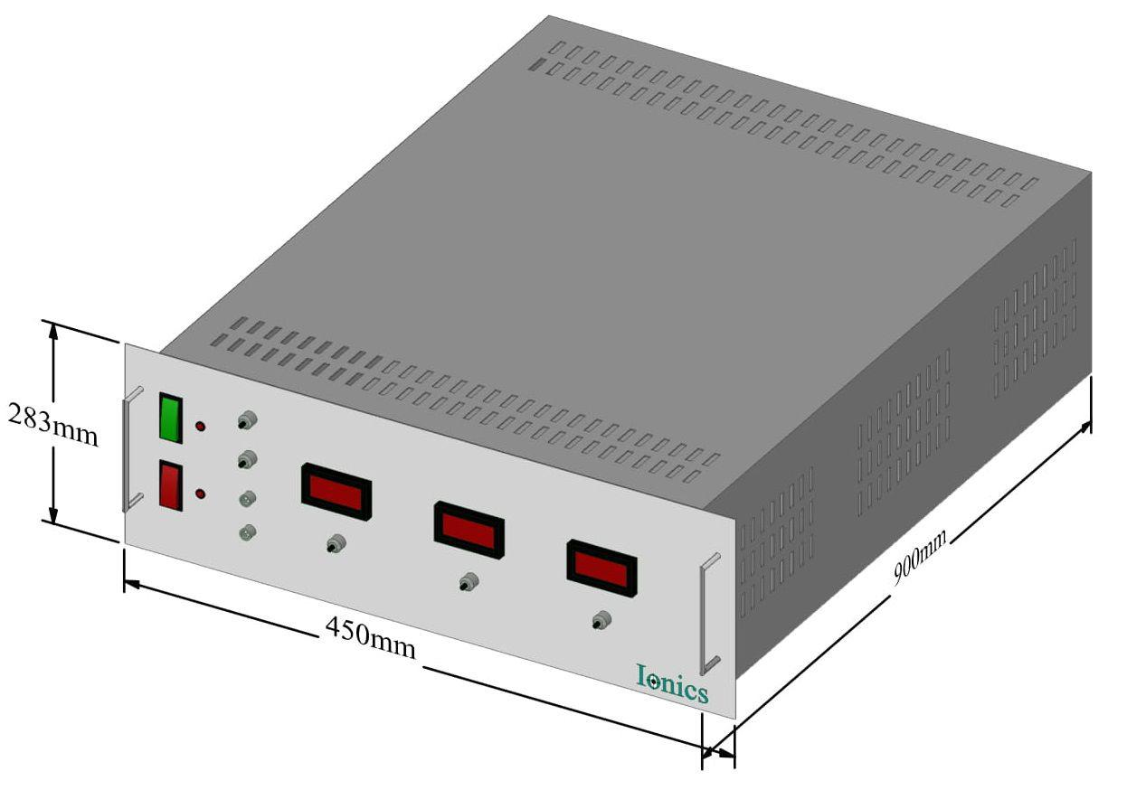
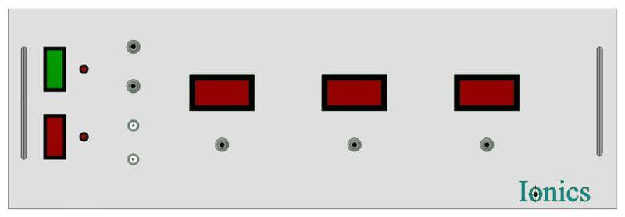
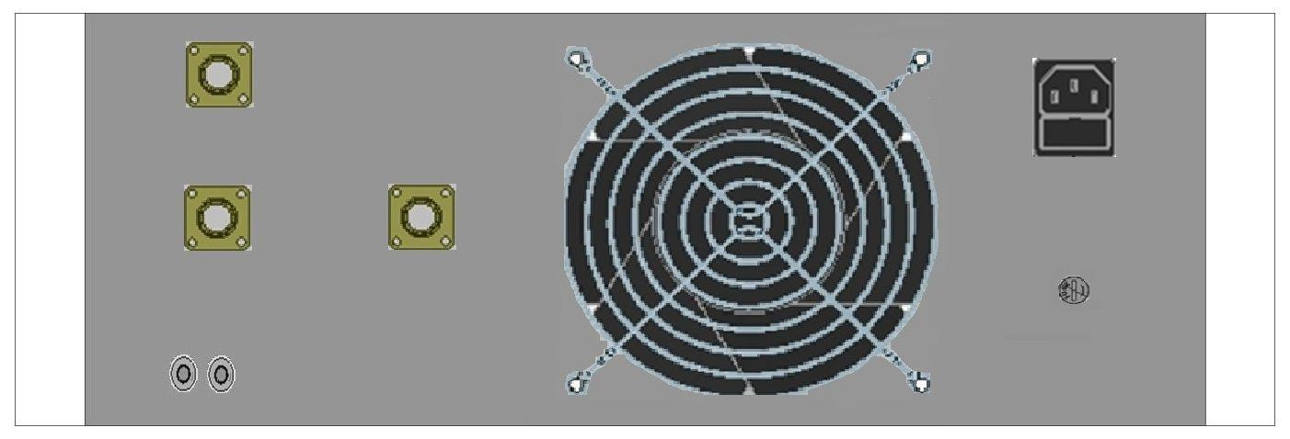

For any queries or customization requests contact us at info@ionics.co.in
For product line information visit us at www.ionics.co.in

